**READ ME Document for technical test**

This document will show how to restore the database in using SQL Server 2022. The great thing about restore is no scripts are required.

Open Management Studio 19

During installation on SQL Server please choose Windows Authentication it makes this a lot easier. In the real world (production) we would have this locked down.

Then just click connect.

Right click on Databases folder inside Microsoft SQL Server Management Studio and choose “*Restore Database”*

This is assuming you already have the back up file from Git. Choose Device, click on … button

Then click on add

Choose the file location of CHS.bak

Then click on OK twice then a third time on this screen. Then you should have the database restored.

Then you should see CHS database.

After SQL Server is installed the above task should only take a minute.

Perform CRUD operations, open Programmability, then open Stored Procedures. This will give you a list of stored procedures for the database.

Add a new Client, right click on Client_Insert

Then click Execute Stored Procedure

Then add first name and last name

Then click OK

Result of Insert

Then to validate Insert right click on Client_Get_All, then execute stored procedure.

No Inputs are required. Click ok

You can now see the new valued enter plus historical records as well.

If you want to update a Clients values use this Client_Update_BY_ClientID, and follow the same steps as above in this instance you enter Client_ID, First_name and Last_Name

If you want to delete a client and all the packages related to that client run Client_Package_Delete_BY_Client_ID.

The Stored procedures are pretty self explanatory as the variables. Again just follow the same steps above for all stored procedures this will cover all the CRUD operations.

This shows dependencies per table

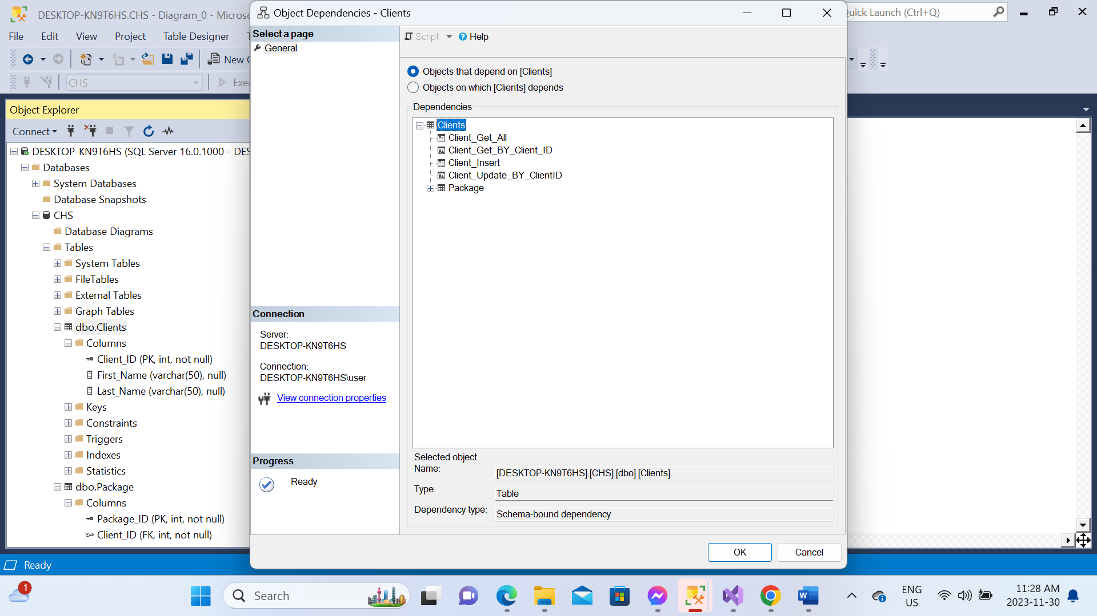

Database Diagram

